**Sivaram Asokan** B.E., MBA., PRINCE2; AWS cloud; Alibaba Cloud; Devops Certified;

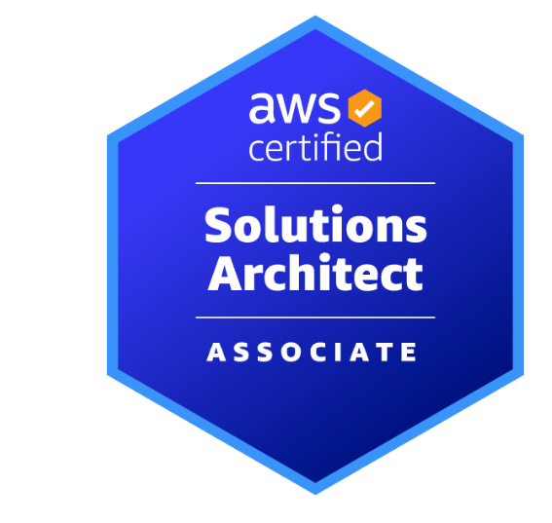 [Sivaram A | LinkedIn](https://www.linkedin.com/in/sivaramasokan/)

**Experience Summary**

I am Results driven Leader of the technology with 18+ years of progressive experience driving operational excellence and strategic initiatives across complex business environments. Demonstrated expertise in team leadership, process optimization, and delivering measurable business results through innovative solutions and effective stakeholder management.

**Skills**

|  |  |
| --- | --- |
| Skills | Category |
| Devops (GIT, Jenkin, Harness, Ansible, Terraform, Confluence, CI/CD), Multi clouds (Alibaba cloud, AWS and AZURE), JIRA, Core Java, TLM, Kafka, Kubernetes, Observabilities(Kibana, Splunk, Dynatrace), Linux (Commands and Scripting), Oracle, and Automation | **Technical Skills** |
| Scope Management, Integration Management, Schedule Management, Cost Management, Quality Management, Resource Management, Communication Management. Incident Management, Change Management, Risk Management, Escalation Management, Stakeholder Management and Scrum Master | **Project and Delivery Management Skills** |
| Microsoft 365(Word, Excel, PowerPoint and Visio), JIRA | **Presentation Skills** |

**Key Competencies**

**Leadership & Team Development**

* Led cross-functional teams of 20+ professionals, fostering a high-performance culture through mentorship and talent development
* Implemented structured performance management frameworks resulting in 25% improvement in team productivity

**Operational Excellence**

* Redesigned core business processes reducing operational costs by 20% while improving service quality
* Implemented automation solutions resulting in 40% reduction in processing time
* Led continuous improvement initiatives achieving 95% customer satisfaction ratings

**Stakeholder Management**

* Built and maintained strong relationships with C-level executives, key clients, and cross-functional partners
* Successfully negotiated complex agreements with strategic partners resulting in $5M+ in new business
* Developed and presented executive-level reports and recommendations driving critical business decisions

**Project & Program Management**

* Delivered multiple high-impact initiatives on time and under budget
* Established PMO best practices and governance frameworks

**Professional Impact**

* Achieved consistent year-over-year growth in revenue, profitability, and operational efficiency
* Recognized for excellence in leadership and innovation with multiple company awards
* Strong track record of developing and promoting team members to leadership positions

**Qualifications**

|  |  |  |
| --- | --- | --- |
| Degree and Date | Institute | Major and Specialization |
| Master of Business Administration (MBA),2020 | Alagappa Institute of Technologies, Karaikudi | Project Management |
| Bachelor of Engineering, Apr, 2003 | Kamaraj College of Engineering and Technology, Virudhunagar | Electronics and Instrumentation |
| Higher Secondary, Apr, 1999 | Kshatriya Vidhya Sala, Virudhunagar | Math and Engineering |
| S.S.L.C, Apr,1997 | Kshatriya Vidhya Sala, Virudhunagar | Math and Science |

**Certifications**

|  |  |
| --- | --- |
| Program | Certified by |
| **PRINCE2**(Foundation and Practitioner) | PeopleCert |
| Ali **Cloud Associate** (ACA) and Ali **Cloud Professional** (ACP) | Ali cloud |
| AWS **Solution Architect** - Associate | AWS |
| Oracle PL/SQL | Oracle Education |
| Advanced Leader (ALB) | Toastmaster |
| **Devops** for AWS | Linkedin |
| Microsoft Project | Linkedin |

**Professional work Experience I in KMCCorp**

|  |  |
| --- | --- |
| Customer | Marriott International, Chennai (Offshore), Mar 2022 to until now |
| Role | Technical Project Manager and Scrum Master |
| Highlights | * Spearheaded extensively on Sprint ceremonies (Sprint planning, User story creation, Story point discussion, Jira dashboard creation, Project plan preparation, Bi-Weekly Sprint presentation and Leadership presentation) * Worked on FinOps cost management through Cloud tags * Championed a culture of innovation, fostering the adoption of emerging technologies to enhance product development and customer experience * Spearheaded Projects through JIRA and Power BI * Ability to handle delivery of large engagements preferably across multiple geographic locations. * Orchestrated Cloud Kubernetes PODs and Managed Cloud Vulnerabilities. * Facilitated effective communication between engineering and other departments to ensure customer requirements are met with quality and efficiency. * Led the implementation of a new project management software, resulting in a 15% increase in team productivity. * Developed and maintained project plans, budgets, and resource allocations, resulting in a 10% reduction in project costs. * Conducted regular project status meetings, identifying and resolving project issues promptly, leading to a 20% decrease in project delays. * Built an in-house DevOps and SRE team from scratch, through hiring and comprehensive training. * Collaborated with stakeholders to define project scope, objectives, and deliverables, resulting in a 25% increase in customer satisfaction. * Ensure security, scalability, and maintainability of products and solutions * Automated the process using Terraform and DEVOPS tools (JIRA, JENKIN and Ansible) saved the time and money. |

**Professional work Experience II in Bank of New York Mellon(BNYM) Technologies**

|  |  |
| --- | --- |
| Customer | BNY Mellon, Chennai, Nov 2013 to Feb 2022 |
| Role | Project Lead/Manager |
| Highlights | * Led the team that manages and enhances the Cloud and DevOps platform supporting more than 20 microservices * Translated business needs into value adding technical solutions * Worked on AI Project deliveries which saved time for the clients * Worked on various infrastructure deliveries such as Webservers, Appservers, Linux Patches, Oracle Databases * Delivered with emerging technologies and digital transformation * Worked on Java Deliveries (Maven, JUnit, Drools, Tomcat, APIs, UI etc.,) * Accelerated to use of tools, infrastructure, and personnel to maximize the engineering team’s output * Identify and implement process improvements through automation and integration * Present technology initiatives and progress to the leadership team as needed * Led the organisation to successfully clear internal and external infrastructure security audits on DEVOPS tools (JIRA, JENKIN, Ansible, Confluence, etc.,) * Worked on Smart Stream TLM Reconciliation Product. |

**Professional work Experience III in Standard Chartered Bank (SCB)**

|  |  |
| --- | --- |
| Customer | Scope International, Chennai. Jun 2010 to Oct 2013 |
| Role | Project Lead |
| Highlights | * Analysing and preparing High Level Design for the new requirements and enhancements based on the User Stories. * Revitalized the codes or software as per the approved design documents. * Worked on Linux based automation to improve the process. * Led the change management process to deploy into Production Environment * Collaborated with clients & Stakeholders while keeping them informed of progress and issues in order to manage expectations on all requirements and deliverables as per signed agreements. * Very good exposure to Project Management Methodologies, ITIL framework and Capital Markets. * Mentored team members to improve process efficiency and achieve targets; Recruited and provided diverse training. * Accelerated to complete Disaster Recovery (DR) |

**Professional work Experience IV in TCS (Tata Consultancy Services)**

|  |  |
| --- | --- |
| Customer | Northern Trust and Tata Communications, Apr 2006 to June 2010 |
| Role | System Engineer |
| Highlights | * Lead architectural decision-making to enforce robust design principles and coding standards. * Define OLA/SLA to deliver the data within stipulated timeline. * Worked on various process automation to make client work very easy. * Performing the feasibility study for the requirements to check against the current system. * Development and testing with UI/UX, Unix shell script and PL/SQL for feeds. * Established IT divisions from scratch, involving design and execution roadmap. * Worked on Regulatory compliance reports * Worked on Bash shell programming to automate the data transfer * Identify and implement process improvements through automation and integration |